
Dear MD. Ali Erdem Yıldırım,
I am writing to advise that your manuscript entitled "BIOCHEMICAL AND HISTOPATHOLOGICAL EFFECTS OF CATECHIN ON EXPERIMENTAL PERIPHERAL NERVE INJURIES" has been accepted for publication in an upcoming issue of TurkishNeurosurgery. We will send the proof of your article for your approval prior to publication. You can reach the final information about your manuscript at online manuscript center (http://turkishneurosurgery.org.tr/submit/). Please find attached Copyright Transfer form. All authors should sign the agreement. Please return a signed copy by fax (0312 215 46 26) or mail.
Please do not hesitate to contact us at any time if you have questions regarding your manuscript or the publication process sending an e-mail to editor@turkishneurosurgery.org.tr
We look forward to publishing your paper.
Prof. Dr. Deniz Belen
Editors in Chief
editor@turkishneurosurgery.org.tr

Doi: 10.5137/1019-5149.JTN.12852-14.2

BIOCHEMICAL AND HISTOPATHOLOGICAL EFFECTS OF CATECHIN ON EXPERIMENTAL PERIPHERAL NERVE INJURIES

Ali Erdem YILDIRIM, M.D¹, Ali DALGIC, Associated Prof. Dr¹, Denizhan DIVANLIOGLU, M.D¹, Rifat AKDAG, M.D², Nuri Eralp CETINALP, M.D³, Fatih ALAGOZ, M.D¹, Fatma HELVACIOGLU, MD⁴, Gulnur TAKE, Associated Prof. Dr ⁵, Yahya GUVENC, M.D⁶,Ismet KOKSAL, M.D⁷, Ahmed Deniz BELEN, Prof. Dr ¹
¹ Ankara Numune Research and Education Hospital, Department of Neurosurgery, Ankara, Turkey
²Bursa Sevket Yilmaz Research and Education Hospital, Department of Neurosurgery, Bursa, Turkey
³Cukurova University Hospital, Department of Neurosurgery, Adana, Turkey
⁴Baskent University Hospital Department of Histology and Embryology, Ankara, Turkey
⁵Gazi University Hospital, Department of Histology and Embryology, Ankara, Turkey
⁶Sincan State Hospital, Department of Neurosurgery, Ankara, Turkey
⁷ Yenimahalle State Hospital, Department of Neurosurgery, Ankara, Turkey

Corresponding Author: Ali Erdem YILDIRIM, M.D.
Tel: 05056875519, Fax: 03123103460
E-mail: alierdemyildirim@gmail.com

Running Title: EFFECTS OF CATECHIN ON PERIPHERAL NERVE INJURIES
Presentation at a conference: 15th WFNS World Congress of Neurosurgery, Seoul – Korea, 2013
Clinical Trial Registration Number: Ankara Training and Research Hospital Ethics Board decision no 2282
BIOCHEMICAL AND HISTOPATHOLOGICAL EFFECTS OF CATECHIN ON EXPERIMENTAL PERIPHERAL NERVE INJURIES

ABSTRACT
Aim: Catechin is a type of polyphenol, which along with epicatechin, epigallocatechin, and epigallocatechin-gallate (EGCG). This study aims to investigate the effect of EGCG, a major metabolite of catechin, which is the principle bioactive compound in green tea, on rats with peripheral nerve injury.
Method: A total of 74 rats were divided into six groups, namely the control, the trauma, the normal saline, a 25 mg/kg EGCG, a 50 mg/kg EGCG and a daily consumption group (10 mg/kg EGCG was given intraperitoneally for 14 days before the trauma). Except the first group, other groups underwent a 1-minute sciatic nerve compression by clip with 50 gr/cm2 pressure. Nerve samples were obtained at day 28 after trauma for the biochemical and histopathological analysis
Result: Our study showed that Daily consumption, 25 mg/kg EGCG and 50 mg/kg EGCG groups demonstrated statistically significant decreased lipid peroxidation levels and particularly daily consumption, and 25 mg/kg EGCG groups showed a favourable reduction of degeneration and edema histologically
Conclusion: This study shows that Catechin and its derivatives have a protective effect on peripheral nerve injury.

Key words: Axonal degeneration, Epigallocatechin-gallate, Electron microscope, Light microscope, Lipid peroxidation, Peripheral nerve injury

INTRODUCTION
Peripheral nerve injury causes loss in the labor force, economic loss and psychological problems. It is a topic of much interest, due to lack of available treatment options. The severity of a nerve compression lesion depends on several factors, including compression pressure, length of pressure, and the area which the pressure affects. Neuronal tissue damage continues after the compression is resolved (25). Compression injury to the nerve induces Wallerian degeneration and axon regeneration, whereas after central nervous system (CNS) injury axons fail to regenerate. These findings were first described by Ramon Y. Cajal under light microscope examinations in 1928 (33). Similarly, the process has also been shown by electron microscopic studies. The post-traumatic nerve tissue changes, observed by electron microscope, include intracytoplasmic edema, and changes in the nucleus, mitochondria, axon and myelin sheath (24).
Similar to the blood–brain barrier in the CNS, there is a blood–nerve barrier in the peripheral nervous system. The blood-nerve barrier regulates the endoneurial microenvironment. Many studies have examined the effect of local experimental compression and intraneural microcirculation, and concluded that 20 – 30 mm Hg external pressure induces a blockage of venous blood flow in the epineurium. Pressure of 80 mm Hg leads to complete cessation of intraneural blood flow (19).
Injury to a peripheral nerve triggers an initiation of a response that incorporates a sequence of biochemical alterations. Severe injury can lead to neuronal edema, more intense neutrophil infiltration, and apoptosis. Increased neutrophil infiltration, myeloperoxidase activity, and the level of tissue malondialdehyde (MDA) lead to an increased level of lipid peroxidation (15). Lipid peroxidation is a toxic process and a self-propagating chain-reaction (6, 15). Lipid peroxidation can impair membrane function directly and damage cell components indirectly. A marked increase in lipid peroxidation is observed after injury. Hall and Braugler reported that lipid peroxidation increases to a peak level at 1, 24 and 48 hours after spinal cord trauma (17).
The tea plant, Camellia sinensis, is a member of the Theaceae family (4, 14, 37). Tea leaves contain polyphenol and polyphenol oxidase enzymes. The main component of green tea extract polyphenol is called catechins. Black tea contains 250 mg/L of catechin, compared to green tea which contains 420 mg/L (40). Approximately 25-35% of the dry weight of tea leaves is catechins. A single cup of green tea contains 100-200 milligrams of catechin (39, 41). The anticancer, antitumor, antimutagenic, chemopreventive, antiproliferative, antiinflammatory, antioxidant, antidiabetic, antiallergic, antihypertensive, antiplatelet, antiobesity, hypocholesterolemic, and neuroprotective effects of catechins have been shown in various in vivo and in vitro studies (36).
The flavonoids contain a double bond and eight isomers. The main catechin group consists of eight polyphenolic flavonoid- type compounds, namely, catechin (C), epicatechin (EC), gallo-catechin (GC), epigallo-catechin (EGC), catechin-gallate (CG), epicatechin-gallate (ECG), gallocatechin-gallate (GCG) and epigallocatechin gallate (EGCG). EGCG is the most prominent flavonoid compound in tea leaves, and has the highest antioxidant activity of all the green tea catechins (ECG > EGCG > EGC > EC) (1, 7, 8, 27, 28, 32). Tea catechins and polyphenols are effective scavengers of physiologically relevant reactive oxygen and nitrogen species, including superoxide, peroxyl radicals, singlet oxygen, and peroxynitrite (10, 13, 16, 29).
The best treatment approach for peripheral nerve injuries remains unclear. In the treatment of peripheral nerve injury, non-steroidal anti-inflammatory and steroids can be used to reduce inflammation, and nerve growth factors, thyroid hormones, growth hormone, ACTH, and insulin like peptides to improve regeneration (11, 20, 31, 35, 38). The aim of this study was to examine favourable antioxidant and anti-inflammatory effects of catechin on peripheral nerve injury.
MATERIAL AND METHOD
Study guidelines and experimental protocol was approved by Ethical Committee of Ankara Training and Research Hospital (decision no 2282) and all experimental procedures were performed at Animal Laboratory of the same hospital. In this study, 74 healthy, adult male Albino Wistar rats, with body weight of 180–210 g, and 3–5 months old, were used. The rats were put in a standard laboratory cage with standardized conditions and sufficient food and water, at 18-21 0C. The rats were exposed to 12 hours of light and 12 hours of dark cycle (26, 30).
The rats were randomized to six groups, including the control group, the trauma group, the normal saline group, 25 mg/kg EGCG group, 50 mg/kg EGCG group, and daily consumption group (10 mg/kg EGCG). The control and trauma groups were include 11 rats, the others grops were include 13 rats. The control group received no injury. The trauma group received compression-induced injury caused by clips, which closed with 50 gr/cm2 pressure, for 1 minute. The third group, the normal saline group, received trauma and daily intraperitoneal injection of 0.25 cc normal saline for 7 days. The treatment groups (group 4 and group 5) were given therapeutic dosages that have been used previously for the treatment of cerebrovascular stroke (36). The fourth group received trauma and intraperitoneal injection of 25 mg/kg EGCG (Sigma-Aldrich, Catalog No E4268®) for 7 days. The fifth group, 50 mg/kg EGCG group, received intraperitoneal injection of 50 mg/kg EGCG for 7 days after trauma. The sixth group, the daily consumption group, received trauma and 10 mg/kg EGCG for 14 days.
The samples were harvested from rats in all groups at 28 days after trauma, and dry tissue samples were transported in a -4 ºC cold-chain for biochemical examination , and the samples, fixed with glutaraldehyde solution, were transported to the laboratory center for histopathologic examination.
The statstically analysis was performed by using t-test and X²-test for SPSS windows 13.
Standard Preparation:
Anesthesia and Surgical Procedure: The rats, which were left hungry for one night, were weighed, and anaesthetized with Xylocaine (Rompun®, 2% solution, Bayer, Istanbul, Turkey) 10mg/kg and Ketamine Hydrochloride (Ketalar®, 5% solution, Parke Davis-EWL, Eczacibasi, Levent, Istanbul, Turkey) 50 mg/kg intraperitoneally prior to surgery (42). Rats were placed in the prone position, and the sciatic nerve, going under the gluteus maximus muscle, was explored through a longitudinal skin incision, at the level of the greater trochanter, proximal to the right lower extremity, and dissected by avoiding tractional damage. Neural injury was produced by compression of the sciatic nerve of each rat for 1 min using an aneurysm clip (Yasargil FE 693 temporary aneurysm clip, Aesculap) with a closing pressure of 50 g/cm2 for axonotmesis nerve injury. Then the incision was closed anatomically. Four weeks later, all rats were anesthesized, and specimens of the damaged sciatic nerves, including 0.5 cm proximally and distally nerve segments, were collected from the prior incision sites. At the end of the study period the rats were sacrificed by administering phenobarbital.
Biochemical examination: The lipid peroksidasion value was calculated for each rats in terms of nanomoles per gram of tissue.
Examination by light and electron microscope: Tissue samples were minced into 1 mm-3 pieces, and fixed in 0.1 M phosphate buffer (pH 7.4) containing 2.5% glutaraldehyde for 2 hours. The samples were washed 3 times with buffer, and 1% osmium tetroxide was used for post fixation. The fixed tissues were dehydrated in alcohol. Finally, the tissues were treated with propylene oxide and then mounted as tissue blocks using the Araldite CY212 kit. The tissues were then polymerized at 56 0C in an incubator for 48 hours, and the cured block was trimmed and made into semi-thin sections and stained in Toluidine Blue solution to be examined with a light microscope. Thin-sections, acquired from marked areas, were stained by uranyl asetate and lead citrate, and observed with Carl Zeiss EVO LS 10+ ED transmission electron microscope (TEM), and were illustrated by appropriate magnifications.
Histopathological specimens were examined by light microscopy, and the changes in myelinated fibers were assessed by histological scoring (Table 1). 12 or more microscopic fields were selected at random from sciatic nerve of each rat and degenerated axons were counted according a protocol which starts from the first right corner of the rectangular field to the last left corner. All samples were evaluated by 2 independent histopathologists blind to the present study.

RESULTS

- Biochemical results:
There was no significant difference between group 1 and group 6, and the treatment groups of 4 and 5 in the statistical examination of biochemical values (p>0.05) (Table 2). However, there was a significant difference between group 2 and 3 as well as groups 4, 5 and 6 (p<0.05). In other words, EGCG administered in daily consumption and in therapeutic doses decreased the level of lipid peroxidation in a statistically significant manner (Figure 1).

- Histological results:
- Light microscopy results:
The samples were harvested from rats in all groups at traumatized area. In Group 1, Schwann cells, and myelinated and non-myelinated nerve fibers were evaluated. Duplication and undulation of the myelin sheath, axonal withdrawal of myelinated nerve fibers, Schwann cell hypertrophy, and widespread tissue edema were detected in Group 2 (Figure 2A-B). Group 3 had similar results to group 2.
In trauma groups was seen that qualitatively, siatic nerve injury consisted of Wallerian degeneration characterized by variable degree of degeneration in great myelinated axons and endoneural edema. Group 4 and Group 6 showed withdrawal of myelin sheath, duplication of myelin sheath, and undulation especially in great myelinated nerve fibers, as in the trauma group. Although these groups also had Schwann cell hypertrophy, edema in myelinated nerve fibers was not observed in these groups. Group 5 showed decreased duplication in myelinated nerve fibers, undulated appearance and Schwann cell hypertrophy, which were observed in the trauma group (Group 2) (Figure 3A-B).
Light microscopy observations showed that based on the distribution of groups related to histopathological changes of myelinated fibers, multiple comparison procedure indicated a statistically significant decrease in myelin sheath seperation, myelin sheath undulation and axonal degeneration in Group 4 and Group 6 compared to Group 2 and Group 3 (p<0.05). In Group 5, intensive degeneration in myelin and axons were found to be significantly higher compared to other groups (p<0.05).

B-Electron microscopy results:
In Group 1, the general structure was considered normal. The endoneural edema and fibrosis, and an increase in type 3 collagen fibers were detected in Group 2. Schwann cells were determined to be hypertrophic. This study showed that there was an increase in lysosomes, expansion in tubulus-system of granular endoplasmic reticulum (GER), mitochondria with dense matrix, and chromatin condensation and dual-membrane separation in the nucleus in Schwann cell cytoplasm. Great myelinated nerve fiber undulation, separation of myelin sheath, and axon withdrawal were detected. Also, the mitochondria with dense matrix were increased in Schwann cell cytoplasm, which comprises the outer boundary of the myelin sheath in great myelinated cells (Figure 4A-4B). The findings of Group 3 were similar to that of trauma group.
In Group 4, small myelinated nerve fibers were in normal morphology and structure. Myelin seperation and rarely axon withdrawal were observed in great fibers. Non-myelinated nerve fibers were in normal structure. There was no endoneural edema in this group contrary to other groups. Schwann cells were recognized with their normal structure and organelle content (Figure 5A-5B). In Group 5 small myelinated nerve fibers had normal structure. Some of the fibres with great diameter showed myelin seperation up to duplication, and undulation, but axon withdrawal was seen rarely. In this group, some of the myelinated nerve fibers showed significant axonal degeneration. Non-myelinated nerve fibers were in normal structure. There were endoneural edema in some regions. In Group 6, myelin structure and axolemma were detected in fibers with small diameter, whereas great myelinated nerve fibers showed myelin sheath separation, axon withdrawal, and swelling and crystolysis in the mitochondria. The cells were hypertrophic. Myelinated nerve fibers were in normal structure through the tissue. Edema, which was observed in trauma groups, was not detected in endoneurium (Figure 6A-6B).
Finally, application of the appropriate doses of catechin was observed to suppress endoneurial edema and increase of collagen fibers and wallerian degenerations ( table 3) caused by trauma. Although catechin was observed to reverse undulation and myelin duplication in myelinated nerve fibers, it was considered insufficient to prevent prominent degeneration in myelinated nerve fibers with great diameter.
DISCUSSION
If the compression pressure on peripheral nerves is higher than capillary perfusion pressure, oxidative stress-induced cell impairment develops after ischemia (9, 24). Antioxidants have potentials to counter the tissue-damaging effect of the inflammatory response. In our study, EGCG, a polyphenol with antioxidant properties, possessed substantial antioxidant activity measured by several biochemical assays in a rat sciatic nerve damage model at daily consumption dose (10 mg/kg) and treatment doses (25 mg/kg and 50 mg/kg), but dense degeneration was detected particularly in axon and myelin sheath with the treatment dose of 50 mg/kg.
Injury to peripheral nerves leads to microvascular damage, which can cause to endoneural edema and promote the increase of endoneural fluid pressure. The removal of compression lead to the resumption of blood flow into nerve cells which not only provide nutrients, including oxygen, but also increases the formation of free oxygen radicals and lipid peroxidation, and this process is called reperfusion injury (24). The central and peripheral nervous systems are rich in myelin, a substance rich in lipids. Release of oxygen-free radicals activated by ischemic-reperfusion injury triggers lipid peroxidation and accelerates tissue damage (34). The products of lipid peroxidation can further damage membrane proteins, including membrane-bound receptors and enzymes by increasing membrane permeability for ions (37). Damage to cell membranes causes ion imbalances, allows extracellular calcium to enter the cell, and leads to edema and necrosis.
Free radicals induce oxidative stress, which is balanced by the body’s endogenous enzymatic and nonenzymatic antioxidant systems. The most efficient enzymatic antioxidants involve glutathione peroxidase, catalase and superoxide dismutase, whereas nonenzymatic antioxidants include vitamins and minerals. The reaction involves the catechin losing a hydrogen atom to a reactive free radical. As chain-breaking antioxidants, tea catechins are thought to interrupt deleterious oxidation reactions (12). Similarly, catechins chelate metal ions such as copper and iron to form inactive complexes and prevent the generation of potentially damaging free radicals (3). Also, catechins have been found to inhibit lipoxygenase and cyclooxygenase activity, enzymes which are capable of increasing oxidative stress or damage in some tissues (18, 21).
Catechin appeared to limit neuronal damage. It was shown that 6-hydroxydopamine-induced nuclear factor-kappaB activation and cell death was attenuated by tea extracts in neuronal cultures (23). EGCG, helps to prevent ethanol-associated apoptosis in fetal rhombencephalic neurons, and presents anti-apoptotic effect on liver (22, 32).
Sutherland et al. found in their study that catechins’ actions of attenuating oxidative stress and the inflammatory response may account for their confirmed neuroprotective capabilities following cerebral ischemia. It was found that EGCG had a dose-dependent response with 25 and 50 mg/ kg eliciting significant neuroprotection (36). Rahman et al. reported that EGCG might be an appropriate intervention for the treatment of acute cerebral ischemia (32). Chaturvedi and colleagues said that black tea extract might slow progression of Parkinson disease, a chronic, progressive degenerative disorder (5). Bastianetto et al. showed the protective effect of catechin derivatives in black tea on amyloid-dependent neurotoxicity (2).
Experimental research with mice has shown that EGCG causes severe hepatic necrosis and 67% mortality when given daily at 50 mg/kg ip. In fact, clinical preparations of tea extracts have also exhibited hepatotoxic effect (39). In contrast, there is evidence that purified green tea extracts in vivo are hepatoprotective. These results suggest that the route and method of administration may determine whether catechins induce hepatotoxicity or have hepatoprotective effects (39).
In the present study, comparison of biochemical values in tissue samples demonstrated that lipid peroxidation levels in treatment and protection groups, namely Groups 4, 5 and 6, were lower at a statistically significant level than that of Group 2 and 3, but were close to the values of Group 1. EGCG attenuates secondary ischemic damage that follows peripheral nerve injury as it was shown by Sutherland et al. that EGCG also reduces neurodegeneration associated with cerebral ischemic process.
Detailed histopathological examination including myelin sheath separation, ondulation of the myelin sheath, axonal degeneration, and intensive degeneration in myelins and axons were performed. Particularly these values in Group 4 and 6 were found to be lower as compared to that of Group 2 and 3. Intensive degeneration in myelins and axons detected in the treatment group, Group 5, indicated to increased degeneration. As a matter of fact, Sutherland et al. reported that the effective dose of EGCG for ischemia protection and early treatment of cerebral ischemia was 25-50 mg/kg, however, since EGCG given at this dose needs to cross the blood-brain barrier to be effective, lower doses of EGCG may also have both therapeutic and toxic effects in a dose-dependent manner, in well vascularized tissues such as peripheral nerves.
CONCLUSION
Our study showed that EGCG, might be effective in the prevention and treatment of secondary damage related to peripheral nerve injury in daily consumption and low-dose treatment groups. Nevertheless it might induce degenerative process particularly when given at a high dose which necessitates dose dependant further investigations. Despite the absence of concrete correlation of histological recovery and neurological findings, the present study demonstrated that EGCG might have inhibitory effects on neurodegeneration and potentially neuroprotective which might be a critical guide to future studies in this field.

Conflict of interest: None

Referances
- Baek WK, Jang BC, Lim JH, Kwon TK, Lee HY, Cho CH: Inhibitory modulation of ATP-sensitive potassium channels by gallate-ester moiety of (-)- epigallocatechin-3-gallate. Biochem Pharmacol 70: 1560-1567, 2005
- Bastianetto S, Yao ZX, Papadopoulos V, Quirion R: Neuroprotective effects of green and black teas and their catechin gallate esters against beta-amyloidinduced toxicity. Eur J Neurosci 23: 55-64, 2006
- Brown JE, Khodr H, Hider RC, Rice-Evans CA: Structural dependence of flavonoid interactions with Cu2_ ions: implications for their antioxidant properties. Biochem J 330: 1173–1178, 1998
- Cadenas E,Packer L: Handbook of antioksidants, Marcel Dekker İnc. New York, 1996
- Chaturvedi RK, Shukla S, Seth K, Chauhan S, Sinha C, Shukla Y, Agrawal AK: Neuroprotective and neurorescue effect of black tea extract in 6- hydroxydopamine-lesioned rat model of Parkinson's disease. Neurobiol Dis 22: 421-434, 2006
- Cheeseman Kh, Slater TF: An introduction to free radical biochemistry. British Med Bulletin 149: 481-493, 1993
- Dalluge JJ, Nelson BC: Determination of tea catechins. J Chromatogr A 881: 411-424, 2000
- Doss MX, Potta SP, Hescheler J, Sachinidis A: Trapping of growth factors by catechins: a possible therapeutical target for prevention of proliferative diseases. J Nutr Biochem 16: 259-266, 2005
- Fern R, Harrison PJ: The contribution of ischaemia and deformation to the conduction block generated by compression of the cat sciatic nerve. Exp Physiol 79: 583-592, 1994
- Frei B, Higdon JV: Antioxidant activity of tea polyphenols in vivo: evidence from animal studies. J Nutr 133: 3275– 3284, 2003
- Fu SY, Gordon T: The cellular and molecular basis of peripheral nerve regeneration. Mol Neurobiol 14: 67-116, 1997
- Gramza A, Korczak J: Tea constituents (Camellia sinensis L.) as antioxidants inlipid systems. Trends in Food Sci Technol 16: 351-358, 2005
- Guo Q, Zhao B, Shen S, Hou J, Hu J, Xin W: ESR study on the structureantioxidant activity relationship of tea catechins and their epimers. Biochim Biophys Acta 1427: 13–23, 1999
- Gupta S, Saha B,Giri AK: Comparative antimutagenic and anticlatogenic effect of green tea and black tea: a review. Mutation research 512: 37-65, 2002
- Gutteridge JMC: Lipid peroxidation and antioxidants as biomarkers of tissue damage. Clin Chem 41: 1819-1828, 1995
- Haenen GR, Paquay JB, Korthouwer RE, Bast A: Peroxynitrite scavenging by flavonoids. Biochem Biophys Res Commun 236: 591–593, 1997
- Hall ED, Braughler M: Effects of intravenous methylprednisolone on spinal cord lipid peroxidation and Na-K ATPase activity. J Neurosurg 57: 247- 253, 1982
- Hong J, Smith TJ, Ho CT, August DA, Yang CS: Effects of purified gren and black tea polyphenols on cyclooxygenase- and lipoxygenase-dependent metabolism of arachidonic acid in human colon mucosa and colon tumor tissues. Biochem Pharmacol 62: 1175–1183, 2001
- Igarashı T, Yabuki S, Kıkuchı S, Myers RR: Effect of acute nerve root compression on endoneurial fluid pressure and blood flow in rat dorsal root ganglia. J Orthop Res 23: 420-424, 2005
- Kanje M, Skottner A, Lundborg G: Effects of growth hormone treatment on the regeneration of rat sciatic nerve. Brain Res 475: 254-258, 1998
- Katiyar SK, Mukhtar H: Inhibition of phorbol ester tumor promoter 12- tetradecanoylphorbol- 13-acetate-caused inflammatory responses in SENCAR mouse skin by black tea polyphenols. Carcinogenesis 18: 1911–1916, 1997
- Katunuma N, Ohashi A, Sano E, Ishimaru N, Hayashi Y, Murata E: Catechin derivatives: specific inhibitor for caspases-3, 7 and 2, and the prevention of apoptosis at the cell and animal levels. FEBS Lett 580: 741-746, 2006
- Levites Y, Youdim MB, Maor G, Mandel S: Attenuation of 6- hydroxydopamine (6-OHDA)-induced nuclear factor-kappaB (NF-kappaB) activation and cell death by tea extracts in neuronal cultures. Biochem Pharmacol 63: 21-29, 2002
- Li Y, Bickel KD, Im MJ, Hu L, Dellon AL, Vander Kolk CA, Manson PN: Effects of deferoxamine on ischemia/reperfusion injury after peripheral nerve compression. Ann Plast Surg 36: 365-369, 1996
- Lundborg G, Dahlin LB: Anatomy, function, and pathophysiology of peripheral nerves and nerve compression. Hand Clin 12: 185-193, 1996
- Macchi MM, Bruce JN: Human pineal physiology and functional significance of melatonin. Front Neuroendocrinol 25: 177-195, 2004
- Mendoza-Wilson AM, Glossman-Mitnik D: Theoretical study of the molecular properties and chemical reactivity of (+)-catechin and (-)-epicatechin related to their antioxidant ability. J Mol Struct Theocem 761: 97-106, 2006
- Nwuha V, Nakajima M, Tong J, Ichikawa S: Solubility study of green tea extracts in pure solvents and edible oils. J Food Eng 40: 161-165, 1999
- Paquay JB, Haenen GR, Stender G, Wiseman SA, Tijburg LB, Bast A: Protection against nitric oxide toxicity by tea. J Agric Food Chem 48: 5768–5772, 2000
- Persengiev S, Kanchev L, Vezenkova G: Circadian patterns of melatonin, corticosterone, and progesterone in male rats subjected to chronic stress: effect of constant illumination. J Pineal Res 11: 57-62, 1991
- Rabinovsky ED: The multifunctional role of IGF-1 in peripheral nerve regeneration. Neurol Res 26: 204-210, 2004
- Rahman RM, Nair SM, Helps SC, Shaw OM, Sims NR, Rosengren RJ: Epigallocatechin gallate as an intervention for the acute treatment of cerebral ischemia. Neurosci Lett 382: 227–230, 2005
- Ramon Y, Cajal S: Degeneration and regeneration of the nervous system. Oxford University Pres, London, 1928
- Schmelzer JD, Zochodne DW, Low PA: Ischemic and reperfusion injury of rat peripheral nerve. Proc Natl Acad Sci 86: 1639-1642, 1989
- Seddon HJ: Three types of nerve injury. Brain 66: 237-288, 1943
- Sutherland BA, Rahman RMA, Appleton I: Mechanisms of action of gren tea catechins, with a focus on ischemia-induced deurodegeneration. J Nutr Biochem 17: 291-306, 2006
- Tang SZ, Kerry JP, Sheehan D, Buckley DJ, Morrissey PA: Antioxidative effect of dietary tea catechins on lipid oxidation of long term frozen chicken meat Science 57: 331-336, 2001
- Van der Zee CE, Brakkee JH, Gispen WH: Putative neurotrophic factors and functional recovery from peripheral nerve damage in the rat. Br J Pharmacol 103: 1041-1046, 1991
- Xuczaj W, Skrzydlewska E: Antioxidative properties of black tea. Prev Med 40: 910-918, 2005
- Yilmaz Y: Novel uses of catechins in foods. Trends in Food Sci Technol 17: 64-71, 2006
- Zaveri NT: Green tea and its polyphenolic catechins: Medicinal uses in cancer and noncancer applications. Life Sci 78: 2073-2080, 2006
- Zhang YL, Zhang PB, Qiu SD, Liu Y, Tian YF, Wang Y: Effects of ketamine-midazolam anesthesia on the expression of NMDA and AMPA receptor subunit in the peri-infarction of rat brain. Chin Med J 119: 1555-1562, 2006

Table and Figure Legends
Table 1: Post-traumatic histologic scores of myelinated nerve fibers. Semi-thin sections of myelinated nerve fibers were assessed with Leica Q Vin 3 program in 5 randomly selected areas.
Table 2: Distribution of Biochemical Measurement Values (Lipid Peroxidation)
Table 3: Distribution of Wallerian Degenerations Measurement in all groups

Figure 1: Multiple Comparison of Lipid Peroxidation Values between the groups Trauma, trauma + saline > control, 10mg/kg, 25 mg/kg, 50 mg/kg respectively.
Figure 2A: Sciatic nerve semi-thin light microscopy sections of normal structured myelinated nerve fibers () as well as hypertrophic Schwann cells (), myelinated sheath duplication () and undulation (),withdrawal of axonal structures on some myelinated fibers (), and generalized edema throughout the tissue (+) is seen (Toluidine Blue X400). Figure 2B: Figure of the same group showing normal structured myelinated nerve fibers (), duplication in myelinated sheath () and undulation (),withdrawal of axonal structures on some myelinated fibers (), and edema of nerve fibers (+) is seen (Toluidine Blue X400).
Figure 3A: The sciatic nerve semi-thin light microscopy sections in the myelinated nerve fibers showing a decrease of the duplication () and undilated appearance () but the myelin sheath is sheltering the axon in some areas () and forming blebs () through axoplasm (Toluidine Blue X400). Figure 3B: Semi-thin sections of the same group showing the normal observed structure of myelinated nerve fibers (),myelinated sheath duplication (), undulated appearance () and intense degeneration () of axonal structures (Toluidine Blue X400).
Figure 4A: Electron microscopy of the Trauma Group sciatic nevre. M1: Myelinated nerve fiber, : Myelinated nerve fiber with undulation, : Decrease of the myelinated nevre fiber electron density before seperation, M2: Unmyelinated nerve fibers, : Unmyelinated nerve fiber with degeneration, S1: Hypertrophic Schwann cell, : Mitochondria with dense matrix inside Schwann Cell cytoplasm located on the border of myelin sheath, : Seperation of myelin sheath, *: Axoneme, : Mitochondria with dense matrix inside the axoneme, : Axon withdrawal, +: Endoneurium edema, : Collagen fiber. Figure 4B: Large magnification electron microscopy images of the trauma group sciatic nerve. M1: Myelinated nerve fiber, : Decrease of the myelinated nevre fiber electron density before seperation, M2: Unmyelinated nerve fibers , : Unmyelinated nerve fiber with degeneration, S1: Hypertrophic Schwann Cell, L: Lysosom, : Mitochondria with dense matrix inside Schwann Cell cytoplasm, S2: Schwann Cell with Nucleus (Ç) like deformation, : Chromatin condensation, : Seperations in the nuclear membrane, : Seperation of myelin sheath up to duplication, +: Endoneurium edema, : Collagen fiber, *: Axoneme, : Mitochondria with dense matrix inside the axoneme, : Mitochondrion in the axoneme with cristolysis (Uranyl Acetate & Lead Citrate).
Figure 5A: M1: Large diameter myelinated nerve fiber, m1: Small diameter myelinated nerve fiber, M2: unmyelinated nerve fibers, *: Axoneme, : Mitochondrion with cristolysis in the axoneme, : Axon withdrawal. Figure 5B: M1: Large diameter myelinated nerve fiber m1: Small diameter myelinated nerve fiber, M2: Unmyelinated nerve fibers, *: Axoneme, : Mitochondrion in the axoneme with cristolysis, S: Schwan Cell (Uranyl Acetate & Lead Citrate).
Figure 6A: M1: Large diameter myelinated nerve fiber, m1: Small diameter myelinated nerve fiber, B: Myelin blebs extending through axoneme, M2: Unmyelinated nerve fibers, : Unmyelinated nerve fiber with degeneration, S1: Hypertrophic Schwann Cell, : Swollen mitochondria with cristolysis inside the Schwann Cell cytoplasm, *: Axoneme, : Mitochondria with cristolysis inside the axoneme, : Axon withdrawal, +: Endoneurium edema. Figure 6B: M1: Myelinated nerve fiber, S1: Hypertrophic Schwan Cell, Ç: Nucleus of the Schwann Cell, : Swollen mitochondria with cristolysis inside the Schwann Cell cytoplasm, *: Axoneme, : Mitochondrion with cristolysis in the Schwann Cell cytoplasm, Li: Lipid droplet, GER: Network of rough endoplasmic reticulum, : Axon withdrawal, +: Endoneurium edema (Uranyl Acetate & Lead Citrate).

Table 1: Histological grading score of nerve injury
Histology Score | Grade
0 | Normal
1 | Duplication of the myelin sheath
2 | Undulation of the myelin sheath
3 | Axonal degenerations (axonal withdrawal)
4 | Nerve fibers with severe degeneration

Table 2: Distribution of Biochemical Values by Groups
Groups | Mean values of  raw data | nmol/gr wet tissue/lipid peroxidation mean values
GROUP 1 | 0.155 | 29.961
GROUP 2 | 0.186 | 35.846
GROUP 3 | 0.187 | 35.961
GROUP 4 | 0.177 | 32.838
GROUP 5 | 0.162 | 31.154
GROUP 6 | 0163 | 31.343

Table 3: Distribution of Wallerian Degenerations Measurement in all groups

Groups | The Number of Axons with Wallerian Degenerations
Gruop 1 (control group) | 7
Gruop 2 (trauma group) | 21
Group 3 (saline group) | 25
Group 4 (25 mg/kg EGCG group) | 32
Group 5 (50 mg/kg EGCG group) | 26
Group 6 (daily consumption group (10 mg/kg EGCG) | 26

Figure 1
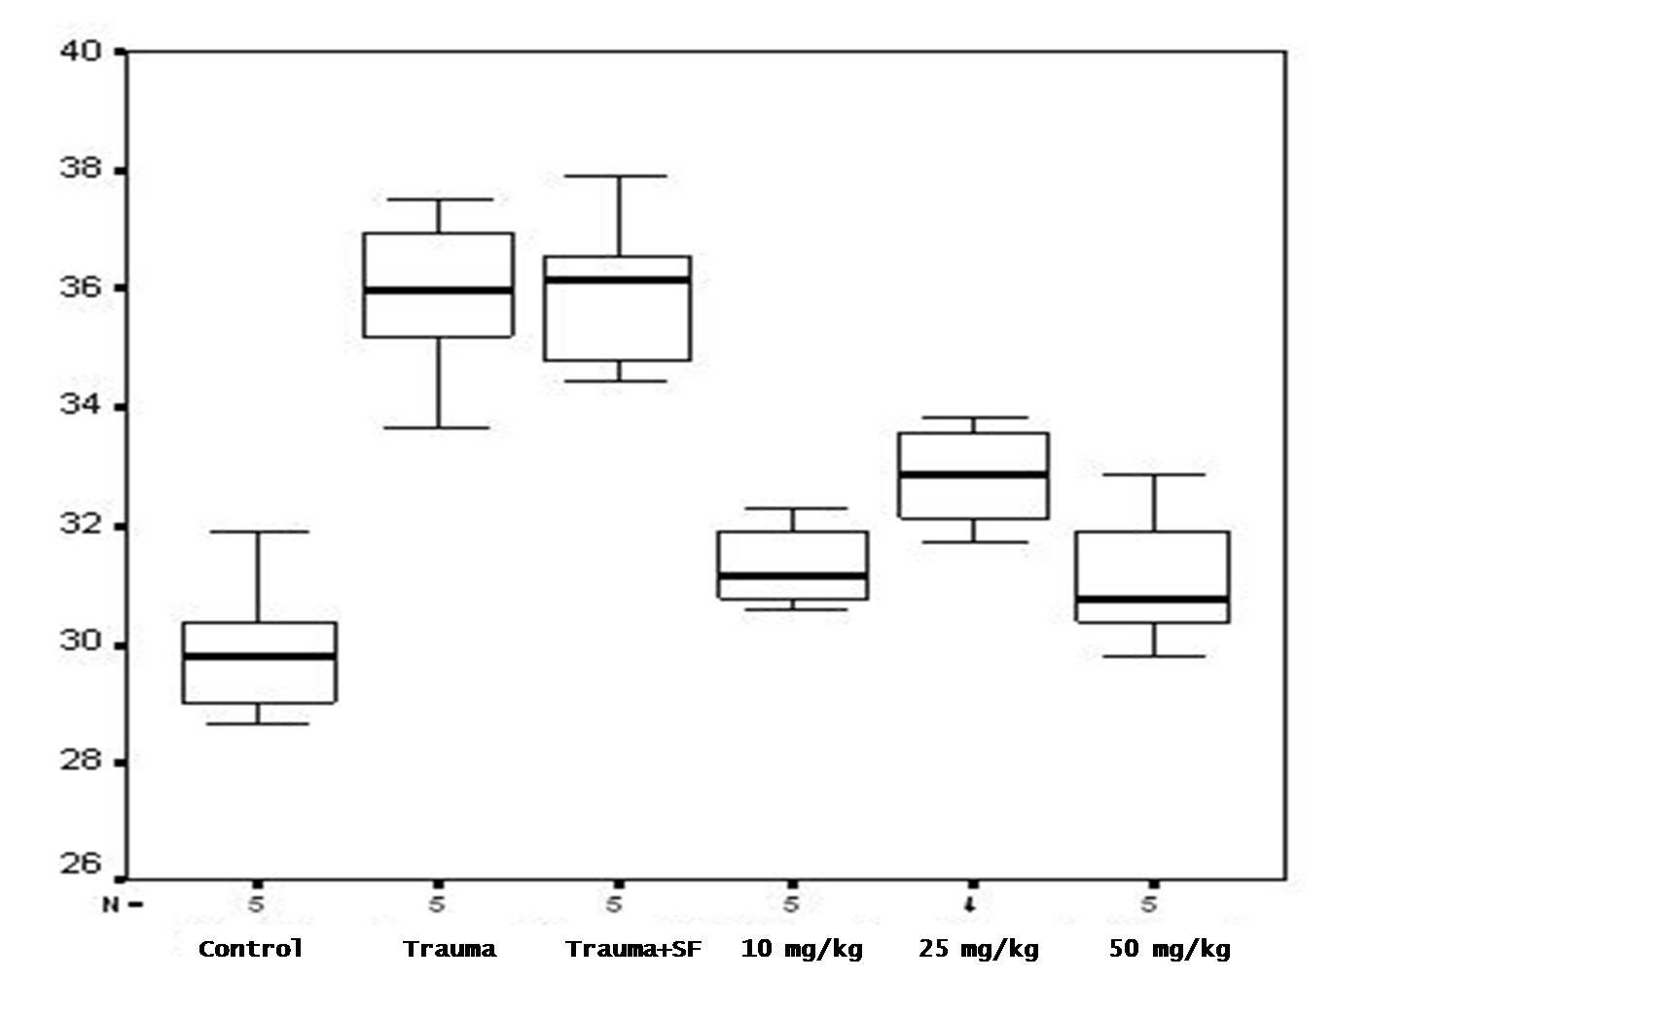
Figure 2
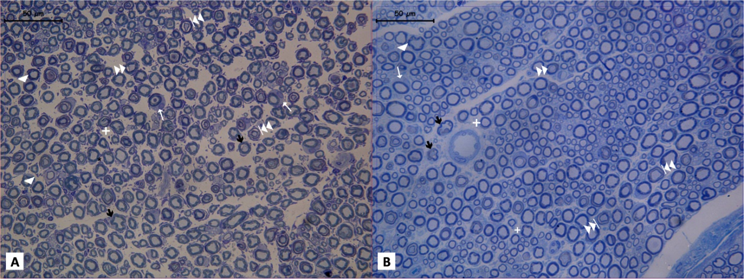

Figure 3
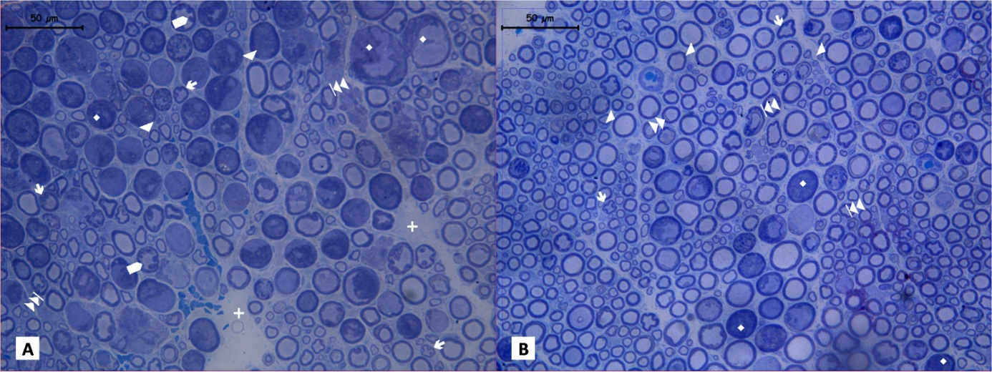
Figure 4
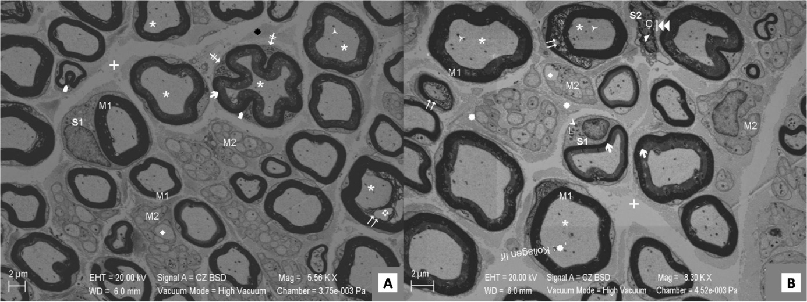
Figure 5
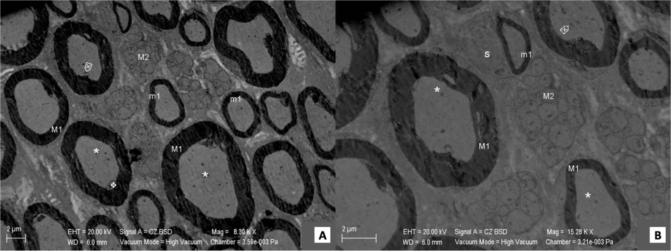
Figure 6
