Editorial Office UTD (dergi@travma.org)
Kime: Ergun Daglioglu (ergundaglioglu@gmail.com)
Bilgi: dergi@travma.org
Konu: Your article is accepted for publication (UTD-54358)

Ref: UTD-54358
Baslik: Deneysel periferik sinir hasari yapilan ratlarda adalimumabin noroprotektif etkileri: Elektron mikroskobik ve biyokimyasal bir calisma - The neuroprotective effects of adalimumab on rats with experimental peripheral nerve injury: an electron microscopic and biochemical study.
Dear. Dr. Ergun Daglioglu
The article that you have submitted to the Ulusal Travma ve Acil Cerrahi Dergisi (Turkish Journal of Trauma & Emergency Surgery) entitled 'Deneysel periferik sinir hasari yapilan ratlarda adalimumabin noroprotektif etkileri: Elektron mikroskobik ve biyokimyasal bir calisma - The neuroprotective effects of adalimumab on rats with experimental peripheral nerve injury: an electron microscopic and biochemical study.' has been accepted for publication following peer review.
We wish you success and hope to communicate with you again.
Recep Guloglu, MD
Editor for the Turkish Journal of Trauma and Emergency Surgery

Doi: 10.5505/tjtes.2015.54358

The neuroprotective effects of adalimumab on rats with experimental peripheral nerve injury: an electron microscopic and biochemical study

Ersin Polat¹, Ergün Dağlıoğlu², Güner Menekşe³, Mehmet Serdar Dike⁴, Çağatay Özdöl⁵, Cezmi Çağrı Türk⁵, Ali Erdem Yıldırım²,Fatih Alagöz², Ali Dalgıç², Deniz Belen²
¹Department Of Neurosurgery, Bafra State Hospital, Samsun, Turkey
²Department Of Neurosurgery, Ankara Numune Training And Research Hospital, Ankara, Turkey
³Department Of Neurosurgery, Ankara Training And Research Hospital, Ankara, Turkey
⁴Department Of Neurosurgery, Ceyhan State Hospital, Adana, Turkey
⁵Department Of Neurosurgery, Antalya Training And Research Hospital, Antalya, Turkey

ABSTRACT
BACKGROUND: Adalimumab, a new generation anti-inflammatory agent, exerts its effect through tumor necrosis factor alpha (TNF-α) which is secreted from immune response cells like macrophages or lymphocytes. TNF-α was proved to have an important role in apoptosis and demyelinization process and blockage of its activity may improve neural healing. Here we investigate probable neuroprotective influence of adalimumab in a rat on peripheric nerve injury model with biochemical and electron microscopic methods.
METHODS: Forty adult Wistar albino rats were divided into sham, sciatic nerve trauma, low dose adalimumab and high dose adalimumab groups at random. Six rats from each group were reserved from biochemical and remaining 4 rats for electron microscopy. Neural injury was induced with clip compression after dissection of sciatic nerves and adalimumab was injected at the same time. Rats were sacrificed after 2 weeks of adalimumab treatment period.
RESULTS: Nerve tissue lipid peroxidation values were found to be statistically significant decreased both in low dose and high dose adalimumab treatment groups when compared with rats subjected to sciatic nerve trauma only.
CONCLUSION: The results of this study showed that adalimumab is an effective neuroprotective agent for neural healing particularly in the early phase.
Key words: Adalimumab, electron microskope study, lipid peroxidation, neuroprotection, peripheric nerve injury, rat, TNF-α

INTRODUCTION
Peripheral nerve injuries are common andimportant causes of long term morbidity.[1] The incidence is approximately2.8% among all cases of trauma.[2]Upon exposure to nerve compression, there may be a spectrum of funcitonal losses from a slight weakness to total paralysis of muscles or from total loss of sensation to a mild paraesthesias. Degree of severity is related to the involved nerve and location, pressure level and duration of the compression. Even after relieving the compression, nerve damage may still continue.[3]Because of ischemic reperfusion injury,responsible from the major damage to the nervous tissue.[4]Ischemic reperfusion injury is mainly initiated by free oxygen radicals and inflamatory reactions, caused by reduction reactions and neurtrophilic infiltrations, respectively.[5]Contemporary management of peripheral nerve injuriesencompasses non-steroidal anti-inflammatory drugs, steroids, nerve growth factors, thyroid hormones, growth hormone, ACTH, and insulin-like peptides.[6,7]In this study, effects of a monoclonal antibody agent, adalimumab, on injured nerve tissue was investigated on an experimental clip compression injury model in arat sciatic nerve.
MATERIALS AND METHODS
40 male Wistar Albino rats, of body weights ranging from 180-210 gr, ages between 3 to 5 months were used for the study. The rats were housed in cages (accomodating 4 rats) in an air conditioned room with controlled temperature (18-21 degrees Celcius) and automatic lightening (alternating 12-hour periods of light and dark). Food and water were given ad libitum.
Rats were randomly categorized into 4 groups: sham group, trauma group, low-dose and high dose of adalimumab groups. The rats were kept overnight fasting and weighed before performing surgical proceduresunder general anesthesia. Rats were anesthesized intraperitoneally by mixture of 10mg\kg Xylocaine (Rhompun ®, a 2% solution, Bayer, Istanbul) and 50 mg\kg ketamine hydrochloride (Ketalar ®, a 5% solution, Parke Davis Pharmaceutical Industries under the license Eczacıbaşı, Levent, Istanbul, Turkey). Anesthesized rats were placed prone position with the extremities attached aside. Superficial sterilization was provided by polyvinylpyrolidone iodine (Polyod ®, a 10% solution, Drogsan Pharmaceutical Industry, Delhi) covering sacral area and both lower extremities. In right lower extremity, a longitudinal skin incision from trochanter level was performed. Following dissection, sciatic nerve was exposed by incising the gluteus maximus muscle vertically. Sciatic nerve were meticulously dissected by preserving perineurium, without any tractional injury. The nerve was compressed for 2 minutes with a temporary aneurysm clip, closing force of 50g\cm2 (Yasargil FE 693 temporary aneurysm Clip- Aesculap). The injured region was marked proximally and distally with polypropylene thread (Prolene). These procedures were repeated for the rats in each group.The Rats in low dose and high dose groups were given adalimumab three times intraperitoneally, during surgery and at 1 and 2 weeks of the injury, in 5mg\kg and 50 mg\kg doses, respectively.
Two weeks later, the rats are sacrificed by high dose of anesthesia and sciatic nerve segments were removed. Tissue samples were cut into 1mm³ pieces and kept in0.1M phosphate buffered 2,5% gluteraldehite (pH 7,4) solution for 2 h fixation. After washing 3 times with a buffered solution, the samples were exposed to 1% osmium tetroxide for 1 hour for postfixation. Later, they are dehydrated in alcohol.Lastly, the samples processed with propylene oxide and blocs were prepared with embedding material by using Araldite CY212 kit. These blocks were polymerized in 560 degree Celsius oven for 48 hours, then semi-thin sections were optained and stained with toluidine blue for examining under light microscopy. From the assigned region, thin sections were taken and stained with uranyl acetate - lead citrate in order to examine under a microscope with EVO LS10 transmission attachment.
In this study, measurement of thiobarbituric acid reactive components were used to ascertain lipid peroxidation as defined by Uchiyama and Mihara.[8]Tissue samples were homogenized in potassium phosphate buffer solution 1:10 (w:v) by using Dounce homogenization. Total of 0,5 ml homogenate was first stirred with 3 mL of 1% phosphoric acid, then 1 ml of 0.67% of TBA was added. Later, the tubes were suspended in boiling water for 45 minutes. After cooling, thiobarbituric acid components were seperated into butanole and absorption values were determined at 532 nm. Taking these values into consideration, thiobarbituric acid reactive components-MDA complex base molar absorption value was determined as 0.156x10⁵ M-1 cm-1and level of lipid peroxide was calculated as nanomoles per gram of tissue.

RESULTS
Test results revealed difference between the measured values in the groups. Analysis showed a statistically significant change in peroxidation values in the trauma group compared to the control group (p=0,02) (Table 1). Moreover, comparison between the control group and adalimumab groups (low and high doses) demostratedstatistically significant differencebetween control group and low dose group (P=0,002) and between low and high dose groups (P=0,009), but not in between the control group and high dose group (P=0,394). Results indicated adalimumab effectively decreases lipid peroxidation, thus having a dose related positive effect on healing of the injured nervous tissue (high dose-low dose comparison P=0,009). High dose adalimumab provided obvious benefit in nerve healing (Table 1).
As a results of electron microscopy, sciatic nerve trauma inducesphagocytic transformations in Schwann cells, particularly those on unmyelinated fibers(Figure 1). These finding concieved as a part of healing process following injury. With adalimumab therapy, at low doses, healing process was thought to accelarete therefor there are fewer number of Schwann cells with phagocytic activities(Figure 2a). Moreover,increase in numbers of mitochondrium was inducedin this group even at low doses of adalimumab(Figure 2b). Positive effect on healing was more striking with higher doses adalimumab, achieving a quite similar cross sectional histological apperance comparable to that of thecontrol group. On the other hand, high dose of adalimumab was shown to cause an increase in numbers of mitochondria and in oxidative stres, too(Figure 3a,b). It was contemplated that high-dose adalimumab, in one respect, accelerates the regeneration process, on the other hand it would have negative effects on myelinated nerve fibers structurally.
DISCUSSION
Factors affecting the healing process after peripheral nerve injury also determines clinical improvement. Besides primary injury to peripheral nerve, nerve compression causing secondary ischemic injury is a well known factor affecting the healing process.[9]Through this process, inflammatory reaction has beneficial as well as the harmful effects on nerve tissue. Following injury, first an extensive degeneration in axons and myelin sheath ensues, then degeneration will turn to regeneration throughout the healing process. Cytokines, particularly TNF- α, plays a major role in the inflammatory reactions. TNF-α has important proinflammatory propertiesin peripheral immune system like regulating antigen presenting cellular activitiesand autoreactive T-cells in apoptosis.[10-13]In overall pathogenesis of inflammatory demyelination, invasion by autoreactive T-cells,in addition to interactionsbetween adhesion molecules and metalloproteinases are important.[14-16]Results of some previous clinical trials on autoimmune arthritis, ulcerative colitis and Crohn's disease, in which increased inflammatory reaction and increased TNF-α levels are accounted in the pathogenesis, provided background forthe assumption that decreased levels of TNF-α may have positive effect on nerve healing.[17]In that respect the adalimumab positive antiinflammatory effectiveness, as shown in psoriasis, rheumatoid arthritis, psoriatic arthritis and ankylosing spondylitis, would have similar beneficial impact on inflammatory nervous system demyelination.[18]This was also demonstrated in an experimental autoimmune encephalitis model; with inhibition of TNF-α, demyelinating lesions in CNS showed regression.[19]
In this study,Schwann cells, particularly on non-myelinated fibers, in the sciatic nerve had pronounced phagocytic transformation which is thought as an indicator of natural healing process. The experiment indicated that even with lower doses of adalimumab, schwann cells with phagocytic functions decreased and, at the same time, healing process was accelerated. More over, it was interesting to note that even with relatively small doses, increase in mitochondria could be induced. With higher doses of adalimumab, regeneration was precipitated, so that a structural apperance compareble to that of control groups could be achieved on histological examinations, particularly in non-myelinated nerves.In terms of healing, there is an obvious difference between myelinated and non-myelinated fibers, may be because of penetration level of the drug intothe target tissues. Following relieving compressive insults on peripheral nerve, ease in thecirculation provides required nutrients and oxygen to nervous tissue. Subsequently, reperfusion injury can ensue with free oxygen radicals and consequent increase in lipid peroxidation.[20]The results indicated adalimumab has statistically significant dose related beneficial effect on decreasing lipid peroxidation, so that it could act like a neuroprotective agent. This study is the first report proving neuroprotective activity paralel to the antiinflamatory effects, being an alternative mechanism in addition to previously reported cyclooxygenase and lipoxygenase pathways.[20,21]
CONCLUSION
This study demonstrated that adalimumab causes particular changes in the phagocytic activity, which has positive effects on healing process in the nervous tissue. Beneficial effects on lipid peroxidation and antiiflammatory activity supported Adalimumab for having neuroprotective properties and being a future candidate agent in patients with peripheral nerve injury.
REFERENCES
1. Li Y, Bickel KD, Im MJ, Hu L, Dellon AL, Vander Kolk CA, et al. Effects of deferoxamine on ischemia/reperfusion injury after peripheral nerve compression. Ann Plast Surg 1996;36:365-9.
2. Lundborg G, Dahlin LB. Anatomy, function, and pathophysiology of peripheral nerves and nerve compression. Hand Clin 1996;12:185-93.
3. Kollias G, Douni E, Kassiotis G, Kontoyiannis D. The function of tumour necrosis factor and receptors in models of multi-organ inflammation, rheumatoid arthritis, multiple sclerosis, and inflammatory bowel disease. Ann Rheum Dis 1999:58:suppl 1:32-9.
4. Van der Zee CE, Brakkee JH, Gispen WH. Putative neurotrophic factors and functional recovery from peripheral nerve damage in the rat. Br J Pharmacol 1991;103:1041-6.
5. Wang X, Hu W, Cao Y, Yao J, Wu J, Gu X. Dog sciatic nerve regeneration across a 30-mm defect bridged by a chitosan/PGA artificial nerve graft. Brain 2005:128:1897-910.
6. Rabinovsky ED: The multifunctional role of IGF-1 in peripheral nerve regeneration. Neurol Res 2004;26:204-210.
7. Robinson WH, Genovese MC, Moreland LW. Demyelinating and neurologic events reported in association with tumor necrosis factor antagonism. Arthritis Rheum 2001;44: 1977-83.
8. Sayan H, Ozacmak VH, Ozen OA, Coskun O, Arslan SO, Sezen SC, et al. Beneficial effects of melatonin on reperfusion injury in rat sciatic nerve. J Pineal Res 2004;37:143-8.
9. Michael C, Feng Z, Lineweavwe WC. Luminal fillers in nerve conduits for peripheral nerve repair. Ann Plast Surg 2006;57:462-71.
10. Hong J, Smith TJ, Ho CT, August DA, Yang CS. Effects of purified green and black tea polyphenols on cyclooxygenase- and lipoxygenase-dependent metabolism of arachidonic acid in human colon mucosa and colon tumor tissues. Biochem Pharmacol 2001;62:1175-83.
11. Fern R, Harrison PJ. The contribution of ischemia and deformation to the conduction block generated by compression of the cat sciatic nerve. Exp Physiol 1994;79:583-92.
12. Cope AP, Liblau RS, Yang XD, Congia M, Laudanna C, Schreiber RD. Chronic tumor necrosis factor alter T cell responses by attenuating T cell receptor signaling. J Exp Med 1997;185:1573-84.
13. Kieseier BC, Krivacic K, Jung S, Pischel H, Toyka KV, Ransohoff RM, et al. Sequential expression of chemokines in experimental autoimmune neuritis. J Neuroimmunol 2000;110:121-9.
14. Kieseier BC, Clements JM, Pischel HB, Wells GM, Miller K, Gearing AJ, et al. Matrix metalloproteinases MMP-9 and MMP-7 are expressed in experimental autoimmune neuritis and Guillain-Barre syndrome. Ann Neurol 1998;43:427-34.
15. Mihara M, Uchiyama M. Determination of malonyldialdehyde precursor in tissues by thiobarbituric acid test. Anal Biochem 1977;86:271-8.
16. Katiyar SK, Mukhtar H. Inhibition of phorbol ester tumor promoter 12-Otetradecanoylphorbol-13-acetate-caused inflammatory responses in SENCAR mouse skin by black tea polyphenols. Carcinogenesis 1997;18:1911-6.
17. Sharief MK, Hentges R. Association between tumor necrosis factor alpha and disease progression in patients with multiple sclerosis. N Engl J Med 1991;325:467-72.
18. Selmaj K, Raine CS, Cross AH. Anti-tumor necrosis factor therapy abrogates autoimmune demyelination. Ann Neurol 1991;30:694-700.
19. Shah SB, Hanauer SB. Risks and benefits of the use of concomitant immunosuppressives and biologics in inflammatory bowel disease. Rev Gastroenterol Disord 2008;8:159-68.
20. Kieseier BC, Kiefer R, Gold R, Hemmer B, Willison HJ, Hartung HP. Advances in understanding and treatment of immune-mediated disorders of the peripheral nervous system. Muscle Nerve 2004;30:131-56.
21. Cope A, Ettinger R, McDevitt H. The role of TNF-α and related cytokines in the development and function of the autoreactive T-cell repertoire. Res Immunol 1997;148: 307-12.

Table 1: The Mann-Whitney U test is used to compare differences between groups

Groups | p values
Trauma-control | 0,02
Trauma and low-dose adalimumab | 0.026
Trauma and high-dose adalimumab | 0.002
Low-dose adalimumab and control | 0.002
High-dose adalimumab and control | 0.394*
High-dose adalimumab and low dose adalimumab | 0.009

FİGURE LEGENDS
Figure1: Electron microscopic examination of trauma group. My: Myelinated nerve fibers, M: Unmyelinated nerve fiber, En: endoneurium, : Schwann cell nucleus, : Axoneme : Degenareted Schwann cells including autophagic vacuoles
Figure2 a: Electron microscopic examination of low-dose adalimumab group, b: Another section of low dose group. My: Myelinated nerve fibers, M: Unmyelinated nerve fiber, En: Endoneurium : Schwann cell nucleus, : Axoneme, : Schwann cells including degenerated and autophagic vacuoles, : Mitochondrias in axonem and Schwann cells
Figure3 a: Electron microscopic examination of high-dose adalimumab group, b: Another section of high-dose group. My: myelinated nerve fiber, En: Endoneurium, : Schwann cell nucleus, : Axoneme, : Mitochondrias in axonem and Schwann cells, : Tubulus of rough endoplasmic reticulum

Figure 1
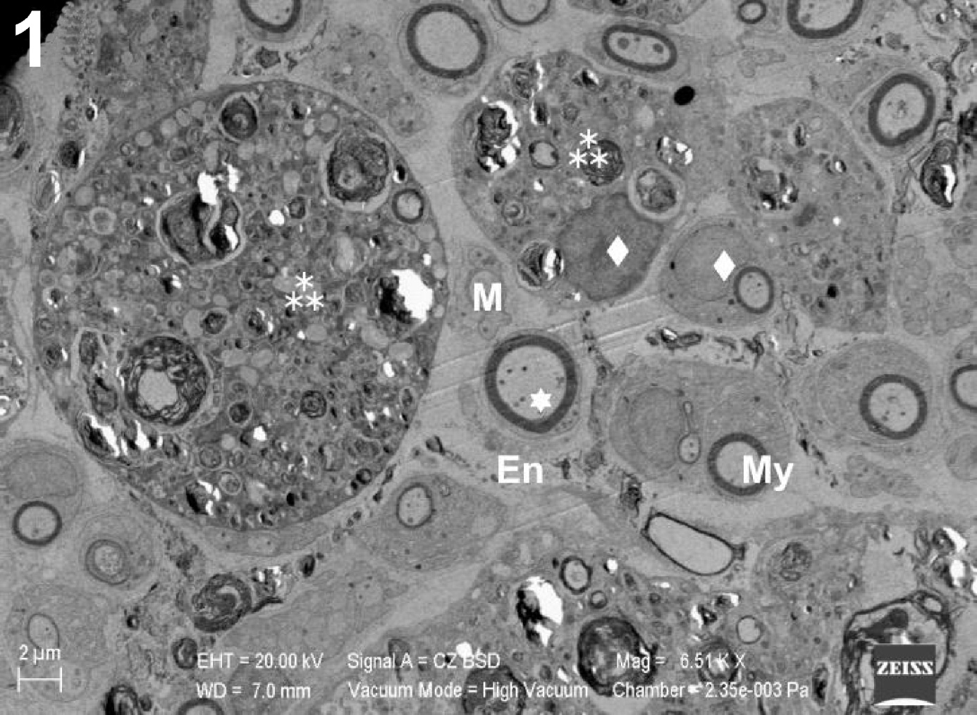
Figure 2
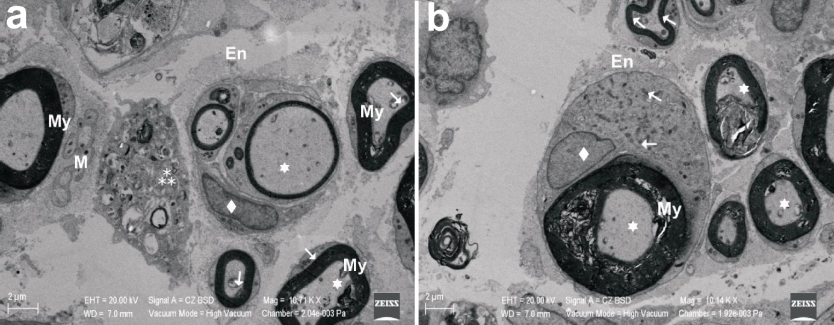

Figure 3
