
Dear MD. Ali Erdem Yıldırım,
I am writing to advise that your manuscript entitled "Massive Skull Base Ameloblastic Carcinoma with Intracranial Extension" has been accepted for publication in an upcoming issue of Turkish Neurosurgery. We will send the proof of your article for your approval prior to publication. You can reach the final information about your manuscript at online manuscript center (http://turkishneurosurgery.org.tr/submit/). Please find attached Copyright Transfer form. All authors should sign the agreement. Please return a signed copy by fax (0312 215 46 26) or mail.
Please do not hesitate to contact us at any time if you have questions regarding your manuscript or the publication process sending an e-mail to editor@turkishneurosurgery.org.tr
We look forward to publishing your paper.
Prof. Dr. Talat Kırış
Editors in Chief
editor@turkishneurosurgery.org.tr

Doi:

Massive Skull Base Ameloblastic Carcinoma with Intracranial Extension

Ali Erdem YILDIRIM, M.D¹, Denizhan DIVANLIOGLU, M.D¹, Derya KARAOGLU, MD¹, Serra KAYACETIN, M.D², Ahmed Deniz BELEN, Prof. Dr ¹

¹ Ankara Numune Research and Education Hospital, Department of Neurosurgery, Ankara, Turkey
²Ankara Numune Research and Education Hospital, Department of Pathology, Ankara, Turkey

Corresponding Author: Ali Erdem YILDIRIM
Tel: +905056875519, Fax: +903123103460, E-mail: alierdemyildirim@gmail.com

Disclosure: None
Running Head: Anterior Skull Base Ameloblastic Carcinoma

Abstract
Ameloblastic carcinoma (AC) is a rare and aggressive malignant epithelial odontogenic tumor which may arise either from the mandibula (66.6%) or the maxilla (33. %3). Besides being formed de novo the tumor can develop from a pre-existing ameloblastoma or odontogenic cyst. The clinical course of AC is typically aggressive with extensive local destruction. AC has also been reported to spread to various parts of the body through lymphatic system. Skull base location and intracranial extension of this tumor are uncommon. In this case report we present the clinical course, management and follow up of an uncommonly large AC which destructed anterior skull base and extended into the intracranial space.

Key Words: Ameloblastic carcinoma, skull base, intracranial

Introduction

Ameloblastoma is benign, slowly growing, but locally aggressive neoplasm which constitutes about 1–3% of all jaw tumors and cysts (18). Ameloblastic carcinoma (AC) is an exceptionally rare and aggressive malignant epithelial odontogenic tumor with a poor prognosis which may arise de novo or from malign transformation of a long-standing ameloblastomas (9, 13). Two thirds of these tumors arise from the mandible while one third originates from maxilla (12). AC may also present as a benign cystic lesion or as a large tissue mass with ulceration, bone destruction and may cause unstable teeth (1). Contrary ameloblastoma case presentations which are commonly published in the literature AC cases especially arising from mandibula are rare (2, 10). Whether this tumor transforms from ameloblastoma or represents a separate entity is still controversial (10). Likewise, there is still no consensus on the management of AC’s however currently as much widespread surgical excision with or without radiotherapy is the preferable treatment modality (6, 16).
In this presentation we demonstrate the clinical course, management and follow up of a particular case that harbors a giant AC extending into the frontal lobe through destructed anterior cranial fossa. While AC’s infrequently seen in this localization this case may contribute to the differential diagnosis of tumors in this area.

Case Report
A 35 year-old male was referred to our institution with the diagnosis of an anterior cranial fossa lesion. He had been suffering consistent headache, numbness in the left half of his face and anosmia for 3 months. There was no facial swelling or asymmetry. He did not express any pain during mastication or any difficulty in jaw movements. His symptoms had rapidly progressed in the last 3 weeks. The patient underwent transsphenoidal biopsy elsewhere before admitting to our clinic of which pathological examination was reported as AC.
Patient’s paranasal computed tomography (CT) scan revealed a soft tissue mass that almost completely occupied the ethmoid cells, nasal cavity, sphenoid and left maxillary sinuses and also destructed lamina paprecea, clivus, and cribriform plate with intracranial extension (Figure 1). Cranial magnetic resonance imaging (MRI) displayed the lesion as solid, lobulated mass enhancing heterogeneously with contrast that showed similar extension pattern seen on the CT by means of compressing both basal frontal lobes (Figure 2). A CT-angiography was performed to rule out any vascular involvement such as internal carotid arteries (ICAs) and to identify the vascularity of the tumor. On CT-angiography tumor was found to be considerably vascular and both ICA’s did not showed any displacement or involvement by the tumor. Laboratory findings including tumor markers were in normal range.
First, we planned to approach the tumor inferiorly by aiming as much gross total resection as possible. The patient underwent an extended endoscopic endonasal transsphenoidal surgery through binostril route. The tumor was reached easily in the nasal cavity. With the help of suction/coagulation and tumor-forceps’ the tumor was removed piece by piece. All tumor parts invading the nasal cavity, the maxillar sinus, the sphenoidal sinus, and the clivus were gross totally removed. Additionally, the tumor-invaded anterior cranial fossa dura-mater was also excised. Although the tumor was soft in nature its highly vascular intra-structure prevented more extensive removal and the intracranial part was left residue. The dura-mater defect was repaired with autologous graft. Postoperative early cranial MRI showed the remnant in the anterior cranial fossa (Figure 3). Histopathological examination revealed an ameloblastic carcinoma, which was consistent with the previous biopsy evaluation (Figure 4). As the second step a transcranial approach was planned on the third postoperative day for removal of the residual tumor since AC has characteristically a poor prognosis and is locally aggressive. A gross total resection with dura excision was performed through the right subfrontal approach (Figure 5). No CSF leakage or any other complications were observed after both procedures and the patient was discharged on the 4th day after the second operation. The patient received 5000 cGy of local adjuvant radiotherapy. The patient was followed up closely and there was no recurrence in 18 months control (Figure 6).

Discussion
Ameloblastic carcinomas are rare encountered lesions. Moreover, their presentations as intracranial extension are uncommon although AC’s usually show an aggressive clinical course with a poor prognosis. AC’s are recognized as malignant epithelial odontogenic tumor which may occur de novo or arise from malign transformation of a long-standing ameloblastoma (9, 13). Most of these tumors originate from the mandible (2/3) and the rest takes its roots from the maxilla (12). AC may also present as a benign cystic lesion or as a large tissue mass with ulceration, bone destruction and may cause unstable teeth (1).
The histogenesis of AC’s and other odontogenic tumors are poorly understood. These lesions may originate from the pluripotent cells of the basal layer of the oral and sinonasal epithelium and also may orginate from ectopic teeth in the nasal cavity (14, 15, 20). The embryological developments of the sinonasal tract and the odontogenic apparatus are closely related to each other. The oral cavity and sinonasal tract communicate with each other since the 10th intrauterine week (12). These cavities are separated by the development of the palatine shelves. During the separation of cavities, the odontogenic epithelium may be trapped in the sinonasal mucosa, or the sinonasal cells may acquire the capability of odontogenesis (7).
Shafer considered AC as a subtype of the ameloblastoma that displays malignant transformation (19). The relevant literature showed that they may occur either de novo or may arise from a pre-existing odontogenic lesion (3, 17). The tumors locate frequently in the posterior portion of the mandible, maxillary involment is seen less common (4). Ameloblastic carcinoma occurs in a wide range of age group without gender predilection (4).
Ameloblastic carcinomas have a more aggressive clinical course than typical ameloblastomas. Bone destructions, surrounding tissue invasions and cervical lymph node metastases can be associated with these lesions (4). Involvement of the nasal cavity usually relates to local invasion of the maxillary ACs. Destruction of the skull base and extension into the intracranial space are unusual and infrequently reported in the literature (13). In this manner, the presented case displays an illustrative example and accordingly AC’s may be taken into account as differential diagnosis among lesions located in the anterior skull base.
The management of AC’s is still controversial. Surgical excision with or without adjuvant radiotherapy is the most preferable common treatment modality (6, 16). While most of the ameloblastic carcinomas are located intraosseously the efficiency of radiotherapy must be evaluated meticulously (10). Chemotherapy is not clearly indicated as primary treatment. En bloc removal with 1–2 cm of healthy bone margin is the safest surgical modality to provide disease-free survival and this resection maintains local recurrence rates of less than 15% (5). AC usually recurs locally 0.5–11 years after final therapy. Laughlin observed that the disease-free interval between the initial diagnosis and the appearance of metastases was 9 years. However, once the metastasis has occurred, the median survival period is about 2 years (8, 11). Because of AC’s this character, we carried out the second operation for gross total removal of the residual tumor.
In conclusion, AC is a rare seen entity which shows very invasive character and can be destructive to adjacent tissues. Infrequently, the tumor may extend into the cranial space. In the management of AC surgical treatment has the priority in which total or gross total removal of the tumor should be aimed. Adjuvant local radiotherapy may be applied after surgery however because of inadequate knowledge this issue is still controversial. When residue or recurrence encountered re-operation may be considered. Patients treated for AC’s must be close followed up with repeated cranial MRI’s.
References
- Avon SL, McComb J, Clokie C. Ameloblastic carcinoma: case report and literature review. J Can Dent Assoc 69: 573–576, 2003
- Batsakis JG, McClatchey KD. Ameloblastoma of the maxilla and peripheral ameloblastomas. Ann OtolRhinolLaryngol 92: 532, 1983
- Cizmeci O, Aslan A, Onel D, Demiryont M. Ameloblastic carcinoma ex ameloblastoma of the mandible: case report. Otolaryngol Head Neck Surg 130: 633–634, 2004
- Corio LR, Goldblatt LI, Edwards PA, Hartman KS. Ameloblastic carcinoma: a clinicopathologic study and assessment of eight cases. Oral Surg Oral Med Oral Pathol 64: 570–576, 1987
- Datta R, Winston JS, Diaz-Reyes G, Loree TR, Myers L, Kuriakose MA, Riqual NR, Hicks WL Jr. Ameloblastic carcinoma: report of an aggressive case with multiple bony metastases. Am J Otolaryngol 24: 64–69, 2003
- Dhir K, Sciubba J, Tufano RP. Ameloblastic carcinoma of the maxilla. Oral Oncol 39: 736–741, 2003
- Guilemany JM, Ballesteros F, Alos L, Alobid I, Prades S, Menendez LM, Cardesa A. Plexiformameloblastoma presenting as a sinonasal tumor. Eur Arch Otorhinolaryngol 261: 304–306, 2004
- Ingram EA, Evans ML, Zitsch RP. Fine-needle aspiration cytology of ameloblastic carcinoma of the maxilla: a rare tumor. Diagn Cytopathol 14: 249–252, 1996
- Kramer IR, Pindborg JJ, Shear M. The WHO histologica typing of odontogenic tumours: a commentary on the second edition. Cancer 70: 2988–2994, 1992
- Kruse AL, Zwahlen RA, Gratz KW. New classification of maxillary ameloblastic carcinoma based on an evidence-based literature review over the last 60 years. Head Neck Oncol 1: 31–32, 2009
- Laughlin EH. Metastasizing ameloblastoma. Cancer 64: 776–780, 1989
- Lolachi CM, Madan SK, Jacobs JR. Ameloblastic carcinoma of the maxilla. J LaryngolOtol 109:1019–1022, 1995
- Ozlugedik S, Ozcan M, Basturk O, Deren O, Kaptanoglu E, Adanali G, Unal A. Ameloblastic Carcinoma Arising from Anterior Skull Base. Skull Base 15: 269-272, 2005
- Ram H, Mohammad S, Husain N, Gupta PN. Ameloblastic carsinoma. J Maxillofac Oral Surg 9: 415–419, 2010
- Schafer DR, Thompson LD, Smith BC, Wenig BM. Primary ameloblastoma of the sinonasal tract: a clinicopathologic study of 24 cases. Cancer 82: 667–674, 1998
- Simko EJ, Brannon RB, Eibling DE. Ameloblastic carcinoma of the mandible. Head Neck 20: 654– 659, 1998
- Slootweg PJ, Muller H. Malignant ameloblastoma or ameloblastic carcinoma. Oral Surg Oral Med Oral Pathol 57: 168–176, 1984
- Small IA, Waldron CA. Ameloblastoma of the jaws. Oral Surg Oral Med Oral Pathol 8: 281–297, 1955
- Thoma K.H. A textbook of oral pathology. In: Shafer WG, Hine MK, Levy BM, eds. 4th ed. Philadelphia: WB Saunders Co. 280–281, 1983
- Woo SB, Smith-Williams JE, Sciubba JJ, Lipper S. Peripheral ameloblastoma of the buccal mucosa: case report and review of the English literature. Oral Surg Oral Med Oral Pathol 63: 78–84, 1987

Legends
Figure 1: Preoperative coronal paranasal CT scan showing the lesion destructing anterior skull base.
Figure 2: Preoperative coronal and sagittal enhanced cranial MRI of the patient demonstrating the huge tumor and its extensions.
Figure 3: Coronal and sagittal enhanced cranial MRI of the patient after the first operation showing the intracranial residual tumor part.
Figure 4: Photomicrograph examples of histology samples proving an ameloblastic carcinoma. Dense basaloid epithelial cells with palisadig, H&E, x40 (A). Immunohistochemical diffuse CK8 sytoplasmic staining of the cells, CK8, x40 (B). Immunohistochemical diffuse CK18 sytoplasmic staining of the cells, CK18, x40 (C). Diffuse P53 staining of the cell nuclei, P53, x200
Figure 5: Coronal and sagittal enhanced cranial MRI of the patient after the second operation demonstrating grosstotal resection of the tumor with some postoperative changes inside the sphenoidal sinus.
Figure 6: Axial and sagittal enhanced cranial MRI of the patient after 18 months for operation demonstrating no reccurens of tumor

Figure 1
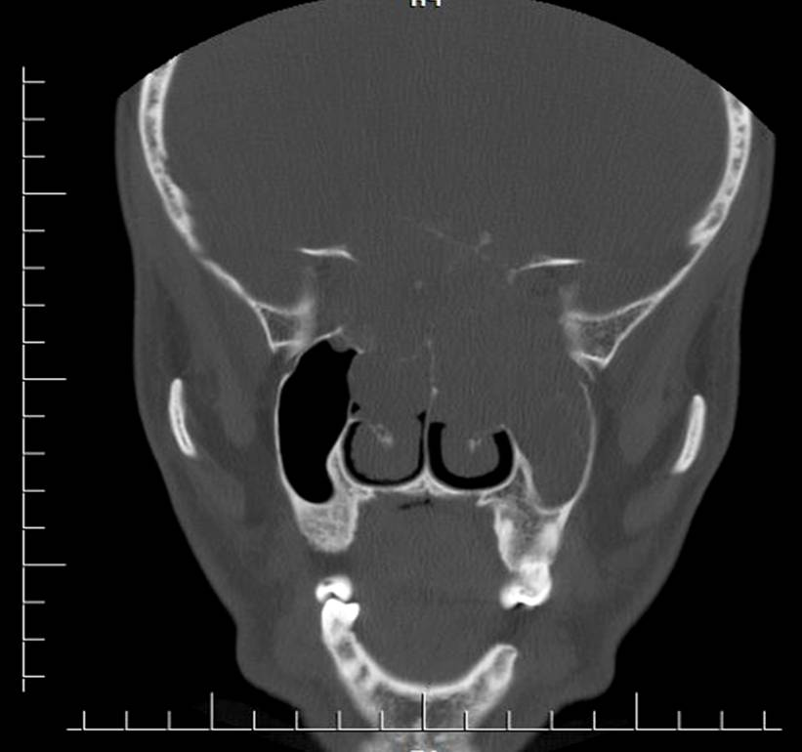

Figure 2
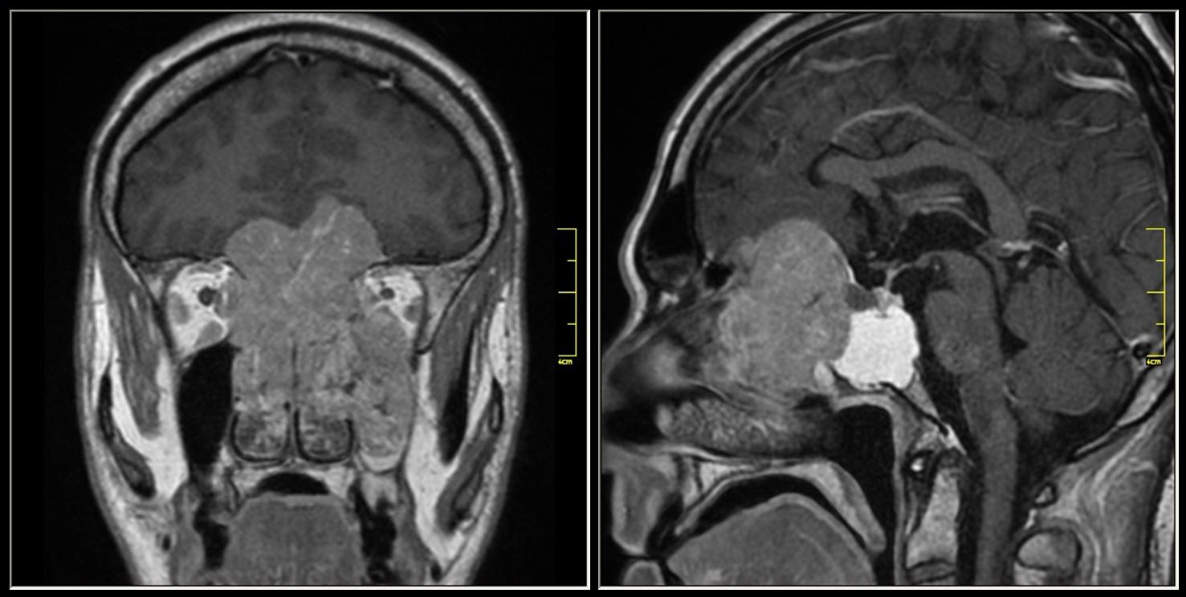
Figure 3
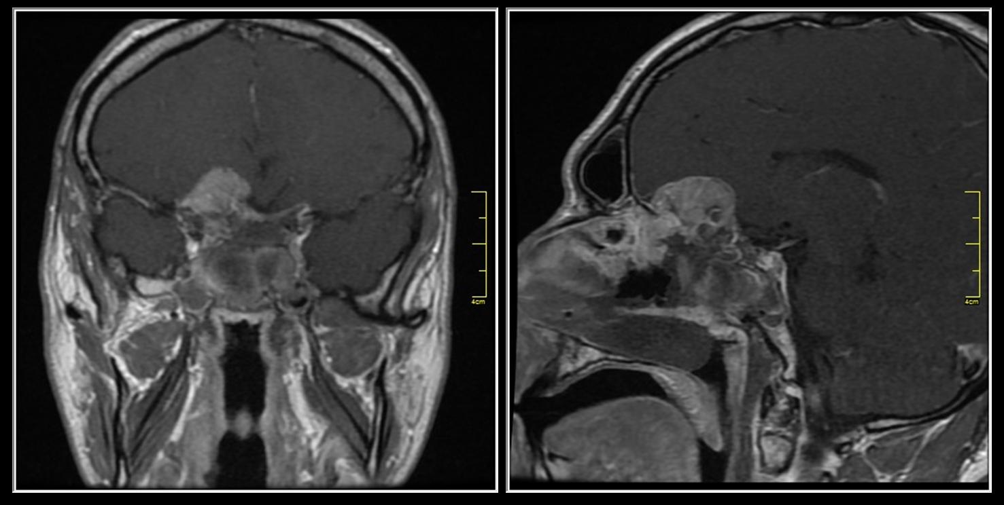

Figure 4
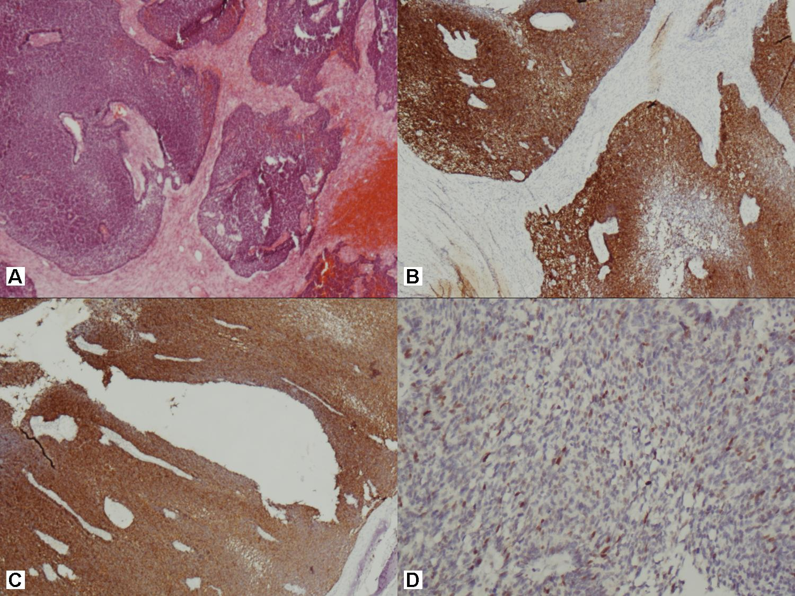
Figure 5
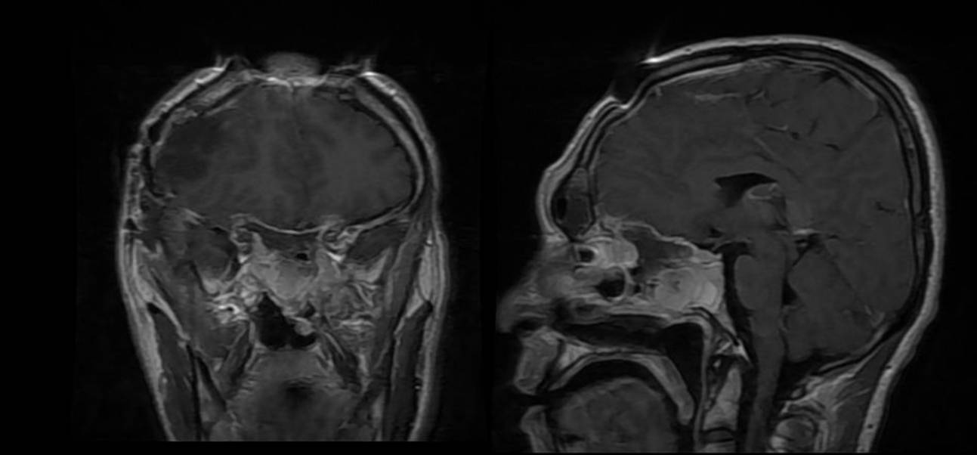

Figure 6
